CN ASSIGNMENT 7

Q1. Design and implement the given network topology with three routers (R1, R2, R3), two LANs, and PC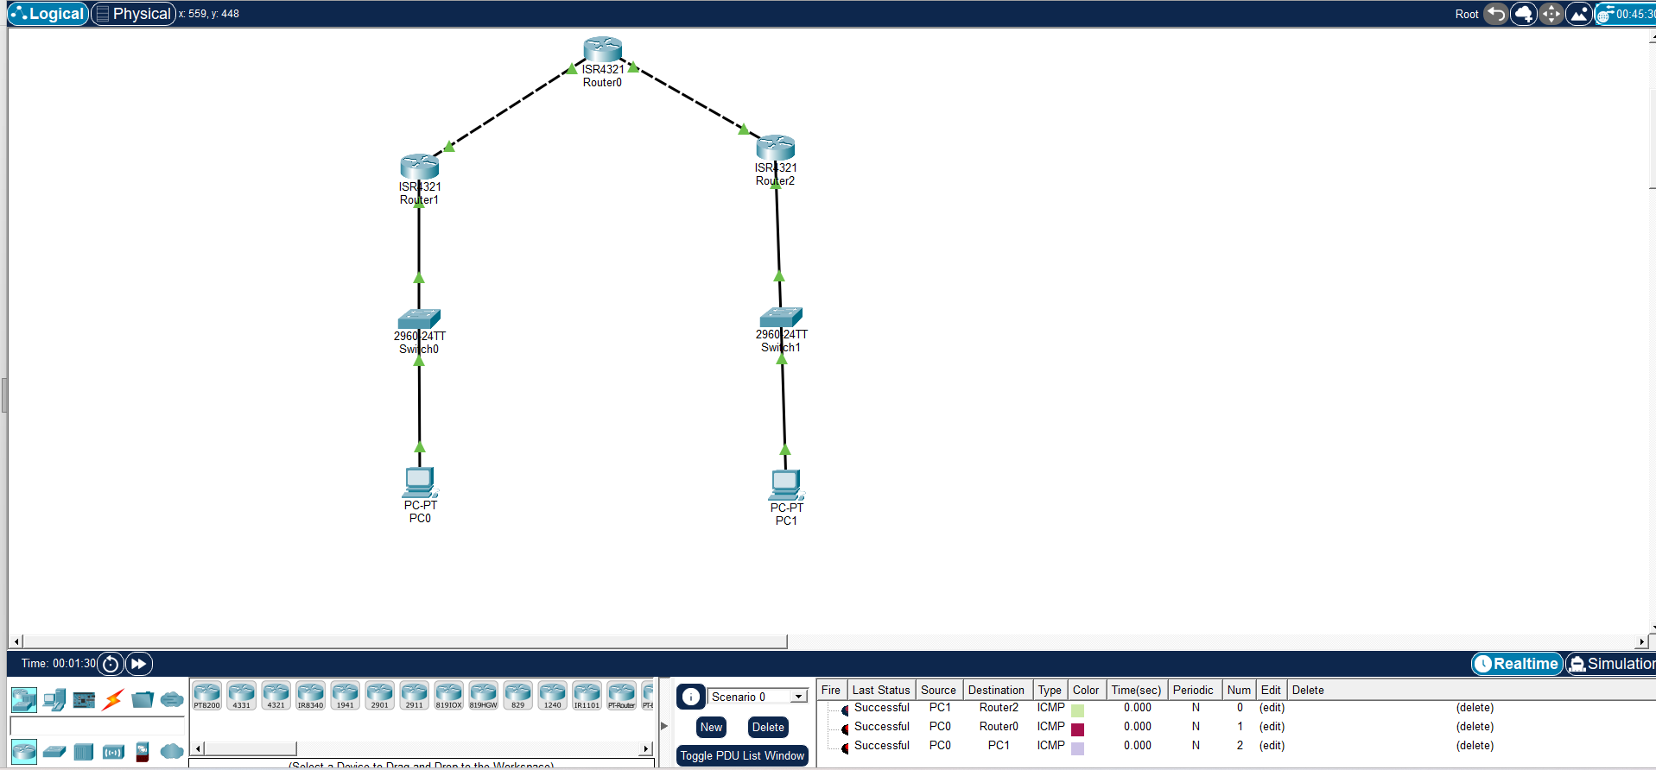

Commands for Router 1
enable
conf t
interface gig0/0/0
ip address 100.1.1.2 255.255.255.0
clock rate 64000
no shutdown
interface gig0/0/1
ip address 20.1.1.1 255.255.255.0
no shutdown
router rip version 2
no auto-summary
network 100.1.1.0
network 20.1.1.0
end
router ospf 1
router-id 1.1.1.1
network 100.1.1.0 0.0.0.255 area 0
network 20.1.1.0 0.0.0.255 area 0
Commands for Router 2
enable
conf t
interface gig0/0/0
ip address 100.1.1.1 255.255.255.0
no shutdown
interface gig0/0/1
ip address 172.16.2.1 255.255.0.0
no shutdown
router rip version 2
no auto-summary
network 100.1.1.0
network 172.16.0.0
end
router ospf 1
router-id 2.2.2.2
network 100.1.1.0 0.0.0.255 area 0
network 172.16.0.0 0.0.255.255 area 0
Commands for Router 3
enable
conf t
interface gig0/0/0
ip address 20.1.1.2 255.255.255.0
no shutdown
interface gig0/0/1
ip address 10.2.2.1 255.255.255.0
no shutdown
router rip version 2
no auto-summary
network 20.1.1.0
network 10.2.2.0
end
router ospf 1
router-id 3.3.3.3
network 20.1.1.0 0.0.0.255 area 0
network 10.2.2.0 0.0.0.255 area 0

